CHAPTER 1

INTRODUCTION

ABOUT THE ORGANIZATION

Alpha-Imager was incorporated in the year 1987 with the primary aim of offering value added services in the field of Electronic system design and software.
Alpha-Imager is a foremost and well-recognized bureau for Printed Circuit Board design and engineering. The Company is providing quality services to most Electronics manufacturing companies and defense laboratories in India and Abroad for the past one-decade and the only design bureau, which has the credit of having designed over 1500 designs.
The Major Business area of Alpha-Imager is as follows:
- CAD service bureau operation.
- Marketing and Support of Electronic System and Software.
- Software Development and Consultancy.
- Strategic Joint Venture for software Export.
1.1.1 Technical Collaboration
Alpha-Imager established a joint venture with Visionics, which is a Sweden based company. “Visionics India” is located in the science ambience of Techno Park, Trivandrum and is developing India’s first indigenous cad package “EDWIN” Electronic Design for Windows is the total integrated Design tool. Users for this CAD package in India include Kirloskar, BPL SANYO, ERL, Instrumentation Ltd, Most Educational Institutes.
Knowing the need of the clients in the dot com world, Alpha-Imager had a joint venture with Belgium based company. “Hallo India”, which is located in the silicon valley of India under STPL, to provide solutions in the field of developing databases and graphics for the web.
The electronic world’s finest requirement is being fulfilled by “NULINE INDIA”, which is an own venture of ALPHA-IMAGER group. “NULINE INDIA” is serving the industry by marketing LCD display, magnetic components, ceramic resonators and OPTO electronic products to Asia and all other European countries.
1.1.2 Software Division
The “Software Division” of Alpha-Imager is satisfying the Client’s requirements by providing reliable services in the area of corporate training, software development and consultancy in various software technologies.

1.1.3 Software Development
Accuracy and security of data, which is involved in any IT & NON IT segments, increased the necessity of automation process. So, development sector of software division is doing the following services.
- Web Site Developing and Hosting
- Office Automation Software’s
- CAD Solutions
- MIS support tools.
- CRM AND E-CRM Packages.

1.1.4 Consultancy
Manpower requirement of the company and clients is being fulfilled through the consultancy services of the Software division. Also the division serves the industries as business a consultancy in the layers of R&D, IIRD, and Marketing & Business development activities.

  - ABOUT THE PROJECT
The project deals with the e-business through reliable and consistent e-DNA system. The e-DNA system would be providing substantial support for the automation of Customer-Reseller-Distributor-Company networking. It is developed to make selling and distribution of the product quicker, reliable and informative. The major advantage of the system is that it retaining all of the existing chaining. Another advantage is that customer can make a purchase without credit card facility. The proposed system will be handling various transactions of distributors, resellers and customers and also administrating distribution.
The project is divided into four modules such as
- Administrator module.
- Distributor module.
- Reseller module.
- Mailing module.
The top executives of the company are kept informed about the progress of the product movement at each stage such that there is a tab as to whether products dispatched are received by the end users. The mailing module facilitates ample communication at the various altitudes of management. This project serves the very purpose for which it is designed in an eloquent fashion.

1.3 ABOUT THE SOFTWARE

Platform : Windows 2000 professional
Server Side Scripting : JSP 2.0, Servlet
Client Side Scripting : Java Script.
Back-End : ORACLE 8.0
Database Connectivity : JDBC
Web Server : Web logic 6.0.
Designer Tool : Macromedia6.0

1.3.1 Overview of J2EE
J2EE is one of the most popular editions of Java in the market today. Sun Microsystems has positioned it to fit multiple purposes in development. The J2EE environment ranges from core java to the most advanced forms of enterprise java technologies like Servlets, JSP, EJB, beans, JMS, JDBC and Web Services etc.
J2EE is designed to deploy applications across the enterprise and to scale to nearly any size needed. The ability to object models, database integration, server components, and Internet/intranet applications provides an extensive range of capabilities and tools for the developer.

Features
- Visual Platform
- Ease of Use
- Flexibility
- Ease of Enhancement
- Easy to Understand
When we consider from the part of the developer J2EE provides facility to develop object models, database integration, server components, and internet/intranet applications that easily. Programming in J2EE has always been building Windows programs. Windows has been one of the most popular graphical user interface (GUI) operating systems, and Sun Microsystems revolutionized enterprise java development with the advent of advanced version of Windows. Windows works in an event-driven environment, meaning the user is in control, and programs need to create and respond to events (such as a mouse click). J2EE became inevitable in providing an elegant interface for working in this environment. And of course, INTRANET or INTERNET adds to its ability to work in a different type of visual environment. J2EE has been popular for one other kind of development-Databases. J2EE gives us even more deployment tools and wizards in the IDE to work with databases.
J2EE made several leaps forward in its ability to build and deploy corporate applications. The addition of classes for object-oriented development, creation of controls, and EJB objects all made J2EE a powerhouse for client/server development. J2EE takes the next steps in moving the language forward to the Internet and building on the robust foundation developed in J2EE. J2EE is used in creating applications of all types, including standard client applications, server applications, and Internet applications..

J2EE has 2 phases
- The Core version is built primarily for creation of stand-alone applications and basic core java programming.
- The Enterprise Edition provides developers with full access to developing solutions, including EJB, beans, JMS, Servlets, JSP, Message driven beans, J2EE Server, Tomcat server, etc.
Sun Microsystems has added significant functionality in several core areas. They are outlined as follows:
- Data Access: A key addition for helping programmers build database applications is support for EJB’s; Sun Microsystems’s new data access technology includes the Data Source Object, which is used for enterprise applications by JNDI look-ups.
- Internet Features: What may be the most significant new functionality is the ability to create both server-and client-side Internet applications. J2EE finally comes to the Internet.
- Component Creation: J2EE continues to emerge as a world-class development tool for creating and working with components ranging from EJB’s to integration with Sun Microsystems’s J2EE or SUNONE application server.
- New and Updated Controls: Sun Microsystems continues its legacy of creating and enhancing controls for supporting rapid application development.
- Language Features: True to the long tradition of J2EE, there have been many language enhancements that make working with strings, numbers, and objects even easier and more powerful.
- Wizards: Deployment tools and other wizards have been added to the tool set to support rapid application development of enterprise-level applications.

1.3.2 Encryption and Decryption Using JCE 1.2 API
JCE 1.2 introduces the concept of secure streams, which combine an InputStream or Output Stream with a cipher object. Secure streams are provided by the CipherinputStream and CipherOutputStream classes.
The javax.crypto.CipherInputStream class is a FilterInputStream that encrypts or decrypts the data passing through it. It is composed of an InputStream or one of its subclasses, and a Cipher. The javax.crypto.CipherOutputStream class is a FilterOutputStream that encrypts or decrypts the data passing through it. It is composed of an OutputStream or one of its subclasses, and a Cipher.

1.3.3 Java Server Pages
JSP, the Java-based technology, is a powerful solution to meet and fulfill the demand for fast and dependable web applications. JSP is an extension of the Java Servlet technology. The features of JSP that have contributed to its acceptance as an attractive alternative to other scripting languages are:
- Platform independence: The use of JSP adds versatility to a Web application by enabling its execution on any computer.
- Enhanced performance: The compilation process in JSP produces faster results or output.
- Separation of logic from display: The use of JSP permits the HTML-specific static content and a mixture of HTML, Java, and JSP-specific dynamic content to be placed in separate files.
- Ease of administration: The use of JSP eliminates the need for high-level technical expertise, thereby helping Web developers, designers, content creators, and content managers to work together and develop Java-based applications in less time and with less effort.
- Ease of use: All JSP applications run on major Web servers and operating systems, including Microsoft IIS, Netscape Enterprise Server, iPlanet Web Server, and Apache Web server. These applications are also available on Windows NT, Windows 2000, and Solaris 7.

1.3.4 Web Logic
BEA Web Logic Server provides an industrial-strength set of services for building e-commerce applications using the Java2 Platform Enterprise Edition (J2EE) standards, including Enterprise Java Beans (EJB) components. BEA Web Logic Server offers the most comprehensive implementation of Enterprise Java standards in the industry.
BEA Web Logic Server includes important new features in these areas:
J2EE Standards - Improvements continue in this release:
- Java 2 security
- HTTP 1.1
- Java Mail
New Platform Services - Web Logic Server now provides:
- JDBC multipools
- Clustered JMS
- In-memory replication of stateful EJBs
- Major web server enhancements

1.3.5 JDBC
Java Database Connectivity (JDBC) is an Application Programming Interface (API) that allows a programmer to abstract a program from a database. When writing code to interact with a database, usually have to add code that talks to a particular database using a proprietary language. To make program to talk to an Access, FoxPro and Oracle databases you have to code the program with three different database languages. This can be quite the daunting task causing much grief.
1.3.6 HTML
HTML (Hyper Text Markup Language) tags are used to design the web pages. HTML is a markup language, which consists of tags embedded in the text of a document. The browser reading the document interprets these markup tags to help format the document for subsequent display to the user. Macromedia Dream weaver MX is the web-authoring tool used to create HTML web pages.
1.3.7 Java Script
JavaScript is a script-based programming language that supports the development of both client and server components of Web-based applications. A bit of scripting has been added as a spice, for handling various events and validations.

1.3.8 Oracle
Oracle is the most widely used database in the world. It runs on virtually every kind of computer, from PC’s and Macintoshes, to minicomputers and giant mainframes. It functions virtually on all these machines.
Development of Relational database started in he early 70’s.By 1980,relational databases were the most spoken of RDBMS. Along with the development of relational databases, and SQL also gained wide popularity.
Reasons for using Oracle as Back end
As Oracle 8.0 is object oriented and robust RDBMS & a number of tools available to work with it makes it quite attractive as a backend.
In a market place populated by computer companies with “proprietary” hardware, “proprietary” operating systems, “proprietary” databases and “proprietary” applications, ORACLE gives business users systems departments’ new control over their lives and futures. They are no longer bound to the database product of a single hardware vendor. ORACLE can run on nearly every kind of computer they can own. This is a basic revolution in the workplace and in application development, with consequences that will extend far into the future.

Benefits of Oracle
- Large Databases: Oracle can be support database ranging from few MB to hundreds of GB. The data files can reside either on hard disks or on CD-ROMs.
- Many Users: It can support from one to hundreds of users. The database management software does all necessary locking and protection of data.
- Large range of Tools: It supplies many tools that provide front-end access to Oracle databases in the form of screens, reports etc. These tools though used mostly with Oracle databases, can also be used with non-Oracle data sources.
- Portable: The Oracle RDBMS software runs on more than 100 different hardware and operating system platforms. If an Oracle application is developed on one machine, it becomes relatively simple to port the application to another machine and operating system.
- Backup and Recovery: If something goes wrong depending on the type of failure, the DBA often needs to do very Little to recover the changes since the database was last running Oracle can also perform ‘hot’ backups of files, which means that backup can be performed while the files are in use.
- Distributed Databases: It enables data physically located in various databases, which may even mean different machines at scattered locations, to be treated as one logical database. The physical structure is hidden from the application programs.
- Security: Standard Oracle database software provides many security facilities, including controlling access to the database, determining the commands that can be run, limiting the amount of resources that can be used by individual processes and defining level of access to data on the database.
- Client/Server Support: Oracle supports a wide range of client and server machines, offering at tremendous choice in platforms for the database engine (the server) and front-end programs (either Oracle front-ends or non-Oracle tools).

1.4 ABOUT THE HARDWARE

Processor : Intel Pentium III
RAM : 128 MB
Hard Disk : 10 GB
Floppy Drives : 1.44 MB.
Display : 14” Samsung Color Monitor.
Mouse : Logitech
Printer : Hp Laser Jet 640c

1.5 ABOUT THE ALGORITHM

Luhn Algorithm

The aim of the algorithms is

- Checks whether the card is of a valid type

- Checks whether the number is a possible credit card number

Visa, Master Card and American Express use an algorithm called Luhn Algorithm to create credit card numbers. These numbers are of a fixed length and predefined prefixes.
Luhn Algorithm involves two steps

First Step
Credit card number is checked to see if the numbers of digits is even or odd. If the number of digit in the given number is odd, double all the evenly placed numbers .If the resulting number is greater than 9,then subtract 9 from the number and replace the corresponding number with it.
If the number of digit in the given number is even, multiply all the oddly placed numbers by 2 and if greater than 9,subtract 9 from it.

Second Step
Add all the numbers, and divide it by 10.If the remainder is 0 then the number is valid Luhn number

CHAPTER 2

SYSTEM STUDY

This section deals with the concept of system analysis, which is the primary phase of the software development. The purpose is to identify the new system and establish what the new system is to accomplish. Moreover, a brief review of requirement determination, a report feasibility analysis and finding are recorded here. System analysis is an important activity that takes place, when a new system is being build. It is the central intact of the system development and it includes gathering necessary data and developing a plan to the new system. It is not an easy task because many people need to be satisfied and many conflicts are to be resolved. System analysis should be creative and imaginative in producing new solutions to meet the user requirements.

2.1 PROBLEM IDENTIFICATION

The existing system is a simple E-Commerce application. The process is tedious and time consuming and not fake proof. The proposed system is developed to bridge the gap between floor selling and E-Commerce. This project sky rockets the sales of the company as well as builds a healthy customer relation at all level.
Existing System provides only the product information online. Developing countries like India, People are not willing to buy the product by seeing such online information of the product, but they want to test the piece in person and want to negotiate for its maximum extend so that they are getting the satisfaction of a purchase with low cost.

2.2 ABOUT THE EXISTING SYSTEM

The existing system deals with E-Commerce. Using this system, customer can buy the products directly from the company without going through the existing channel network, which already got developed by the company. In this case the selling base might increase for the company. But, this would be violating the network, which has been supporting the company for a long time.
Existing System provides only the product information online. Developing countries like India, People are not willing to buy the product by seeing such online information of the product, but they want to test the piece in person and want to negotiate for its maximum extend so that they are getting the satisfaction of a purchase with low cost.
2.2.1 Limitations of Existing System
The existing system never ensures a demonstration process to the customer wherein they will be forced to buy without getting satisfaction.
2.2.2 Problems in the existing system

Transactions are carried out only with credit card facility.

Chance of fake transaction.

Give fewer guarantees for customer order request.

Disposal of existing distributor-reseller network.

Doesn’t provide any assurance regarding product delivery.

Less scope with fully offline system.

2.3 ABOUT THE PROPOSED SYSTEM

Proposed system is a variation of E-Commerce .The system has to be developed will be incorporated into company’s website. A consumer goods manufacturing has number of distributors located geographically. Distributors will have number of resellers dispersed regionally/locally. All the transaction will be handle through this network If user already have an account, will have to log on to the website and they have to select, configure and order products. This means distributor must have an account with company; reseller must have an account with distributor.

2.3.1 Need for Proposed System
The drawback of the existing system is well defined and obviously it forces to draw a new system, which can resolve the drawbacks of existing system. The proposed system should have the following advantages.

- The system should cover the online selling scope for the products
- The system should only support the mileage but the sales should happen through the channel network.
- The system should be completely automated with concurrent needs generated by the customers and it should be supported by well defined logistics system
- The resellers or any downlink channel should have very clear idea about the commitment given to the customers by means of quality as well as time factors.
2.3.2 Features of the proposed system

- Retaining all of the existing channel network (Distributors- Resellers).
- Customer can make a purchase without credit card facility.
- Online administration of distributors and resellers.
- Provides assurance at each stage of product delivery.
- Data validation at the time of data entry
- User-friendly data input screen.
- Security features.

CHAPTER 3

SYSTEM DESIGN

Design has been described as a multi step process in which representation of data structure, program structures interface characteristics and procedural details are synthesized from information requirements. Design serves as a foundation for software engineering and software maintenance steps that follows. It is an activity concerned with making decisions, often of a structural nature. Design builds coherent well planned representation of program that concentrates on the interrelationship of parts at the higher level and logical operations involved at the lower levels depending on the application and project requirements, a design is one which allows efficient code to be produced and whose implementation is as possible.
Data Flow Diagram
The graphical description of the system’s data and how the processes transform the data is known as Data Flow Diagram
A graphical picture of the logical steps and sequence involved in a procedure or a program is called a flow chart.
Unlike detailed flowchart, Data Flow Diagram does not supply detailed description of the models but graphically describes a system’s data and how the data interact with the system.

  - SYSTEM DESIGN

    - System Flow Chart

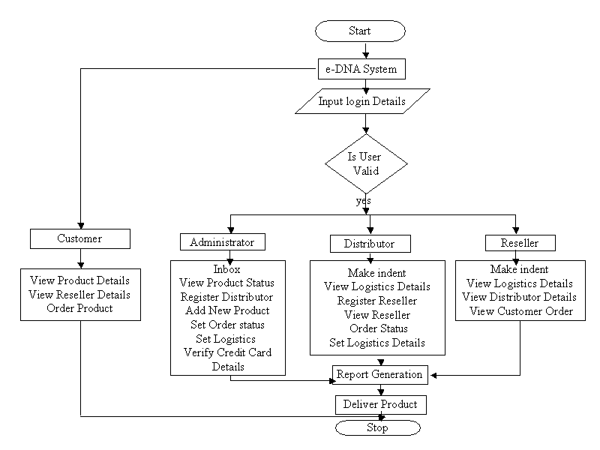

Fig. 3.1 System Flow Chart for e-DNA System

    - DATA FLOW DIAGRAMS

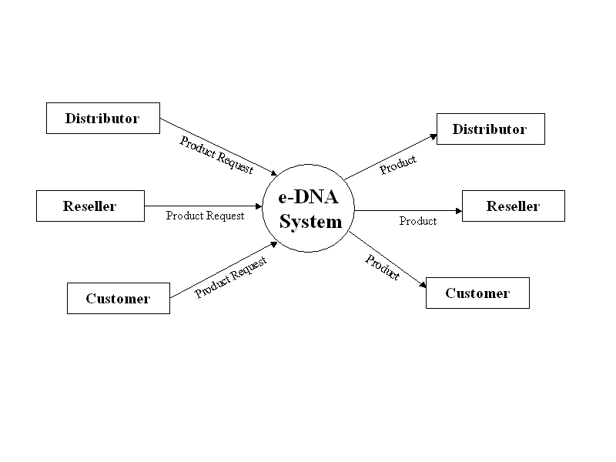 Fig. 3.2 Level 0 DFD For e-DNA System
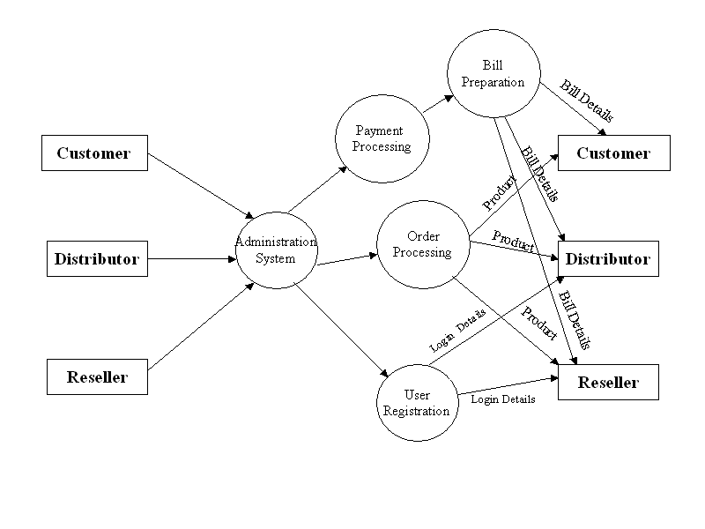 Fig. 3.3 Level 1 DFD For e-DNA System

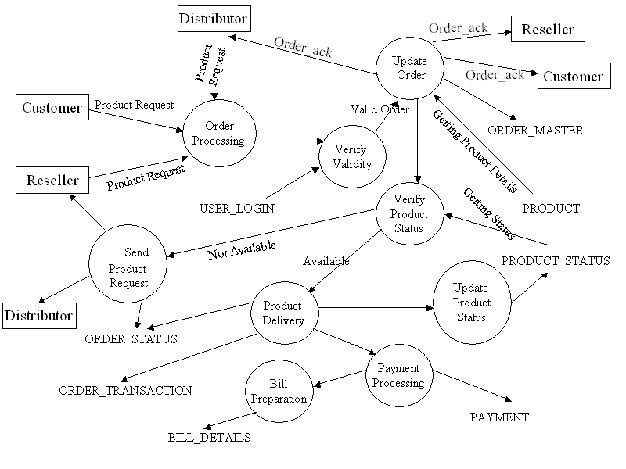

Fig. 3.4 Level 2 DFD For Order Processing

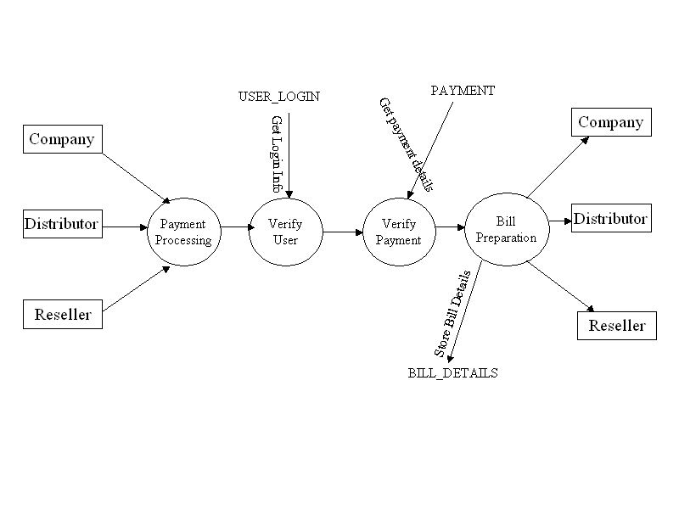
Fig. 3.5 Level 2 DFD For Payment Processing
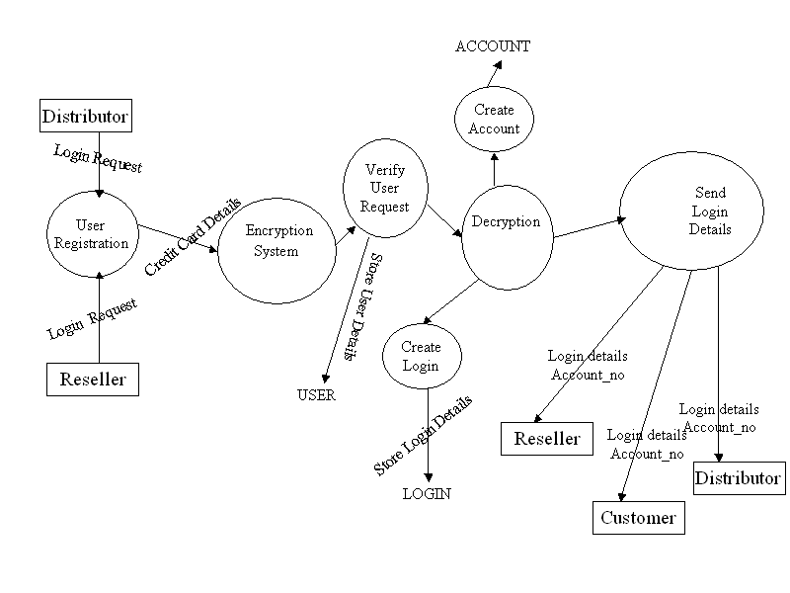
Fig. 3.6 Level 2 DFD For User Registration

  - INPUT DESIGN

Input design is the process of converting user-originated inputs to a computer-based format. It is the interface between the user and the system. An interface implies a flow of information. The most exciting trend in interface design is windowing. The user manipulates windows with a mouse. Even though the windowing environment is often considered to be graphical, some applications include manipulation of windows through keyboard.
Input design in “e-DNA ” ensures secured inflow of data in a user-friendly way by means of the input forms that are displayed in Browser. This project contains forms like Indent making from distributors and resellers, enquiries from customer, Setting Status, Setting logistics information, Feedback form from distributor, reseller, and customer.
3.2.1 Admin module
The admin module consists of the input forms like Registration of Distributor and Reseller, editing the registration details, Adding new products and category, updating the offer details, setting status for distributors cumulative indent and setting logistics for the indent.
The User Login Registration is the important input form of the admin module. The Username and Password are generated automatically using registration details. The User will be given username and password through mailing system. User name and Password are validated using existing user login table.
New product introduction is done by the admin through add new product form. Product details like Product id, Product name, Product description, Product category, and Retail price, Product Image are entered by the admin.
The offer description about the product is entered by the admin through update the product. The offer description about the product like valid period, percentage of discount and relevant details. This form helps the admin to calculate total amount of particular product after processing the discounts offered.

Admin set the status for the distributor’s indent using Set Status. The Set Status form contains indent details of particular distributor, Acceptance and on process of the ordered quantity.
Admin reserves the rights to set the Logistics information for the entire channel by updating the details like indent number, date, batch code, date of exodus and pack quantity.
3.2.2 Distributor Module
The Distributor module contains the input design forms like Make Indent form, Setting status for Reseller indent, Setting logistics and comments to Company and Comments to Reseller.
The Make indent form contains details like indent number; indent date, which are automatically generated. The distributor has to select category and products to enter the quantity required for each product. The distributor can also remove those products, which are wrongly entered. Finally cumulative indent will be forwarded to the company.
Setting Status for the Resellers will be based on ordered quantity. The Status of particular product will be updated either under “Accepted” category or under “on process”. The above information will be forwarded to the Resellers and they can view the same through “view status".
The next important form is the logistics settings for the indent. The Reseller is informed that the particular indent information like indent number, date, batch code, date of exodus, pack quantity by which channel it reaches the reseller.
The distributor can pass their comments to company as well as resellers by using the input forms of “Comments to Company” and “Comments to Reseller” accordingly through mailing system. In general, this facility will be used by the Distributors either to solve clarifications or to update any problem occurring in delivery process of the goods.
3.2.3 Reseller module
The Reseller module contains the input design forms like Make Indent form, Comments to Distributor, Customer, and Customer Address Book.
The Make Indent form contains details like indent number; indent date, which are automatically generated. The reseller has to select category and products to enter quantity required for each product. The reseller can also remove those products, which are wrongly entered. Finally cumulative indent will be forwarded to the Distributor through this form.
The reseller can send comments to the Distributors through mailing system regarding any clarifications needed or to update any problem in delivery process of Goods.
The enquiry from customer is entered using Customer Enquiry Form, which will be having the provision to select products from various categories listed in the site. Also it has the input facilities to enter their contact address and Delivery address.
All fields of input forms are checked with the concept of Validation Checking using Script coding.

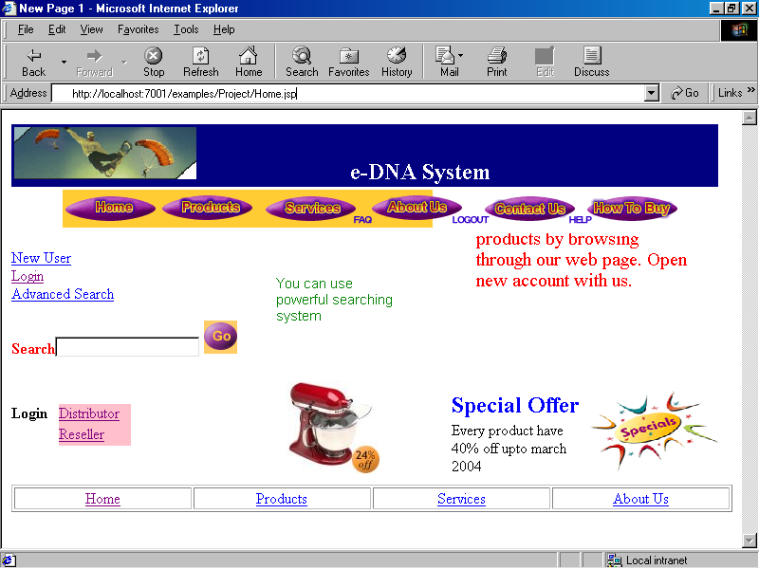

Fig. 3.7 Home Page

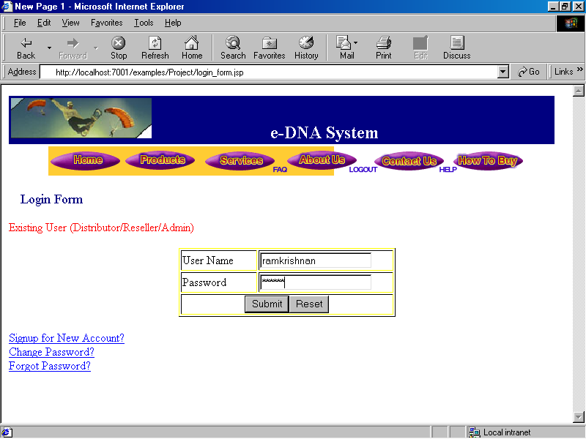

Fig. 3.8 Login Screen

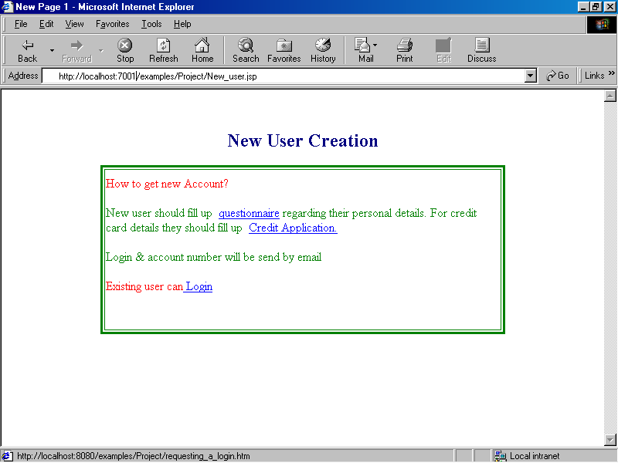

Fig. 3.9 New User Creation

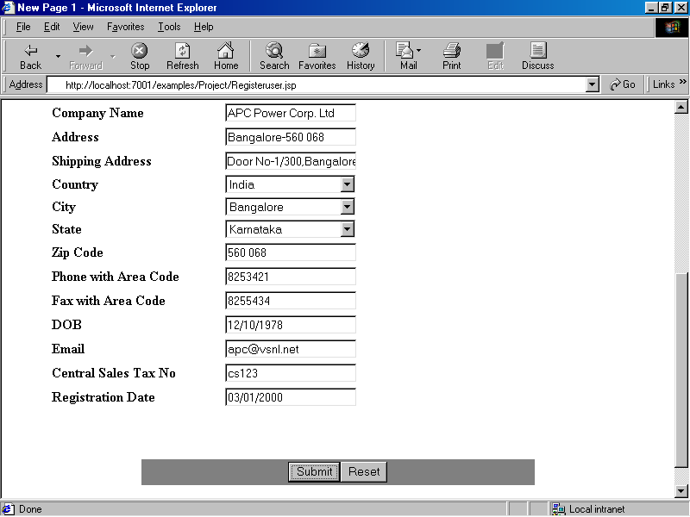

Fig. 3.10 User Personal Details
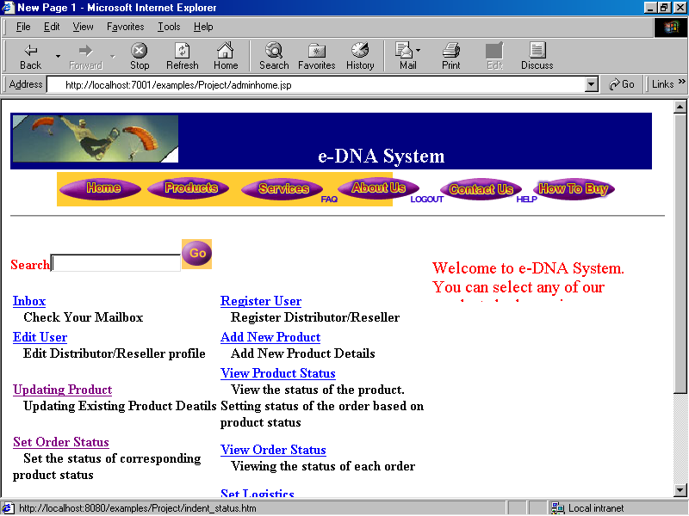

Fig. 3.11 Admin Home Page

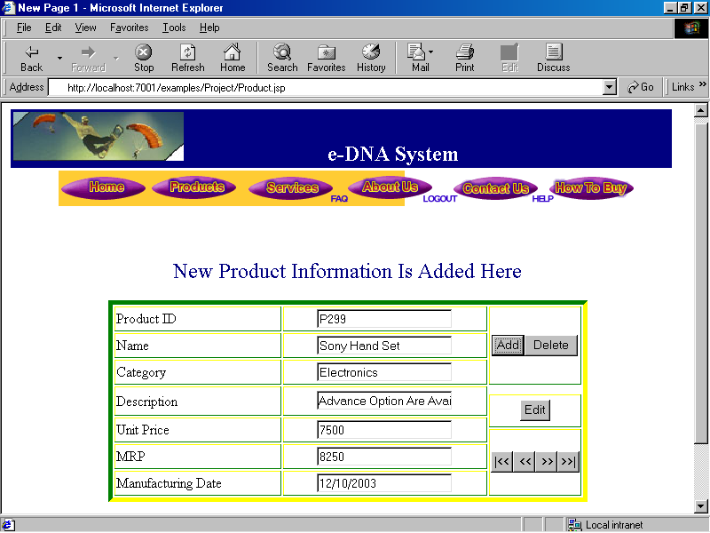

Fig. 3.12 Product Details
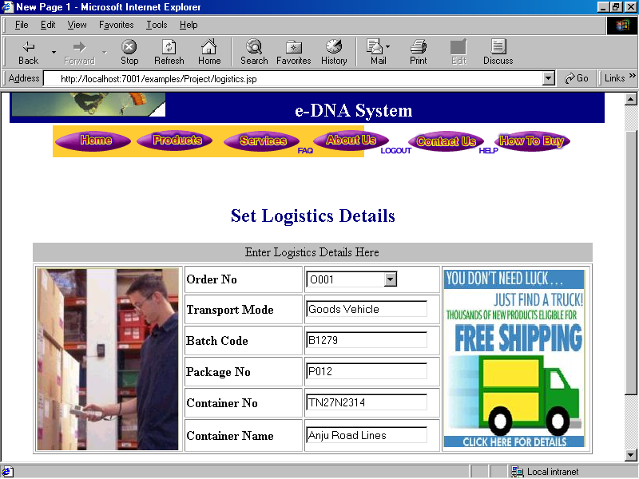

Fig. 3.13 Set Logistics Details

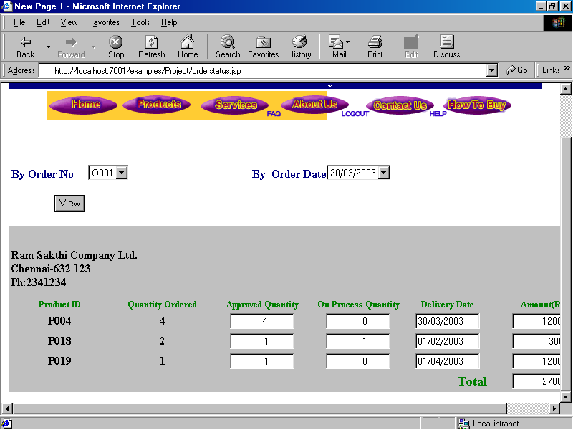

Fig. 3.14 Set Order Status
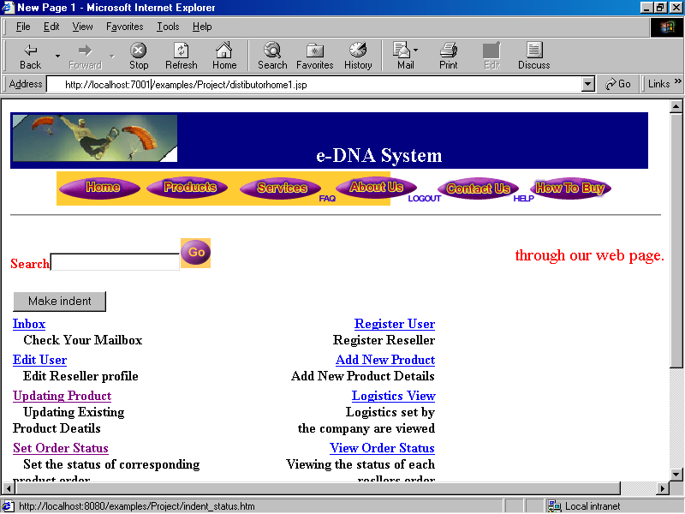

Fig. 3.15 Distributor Home Page

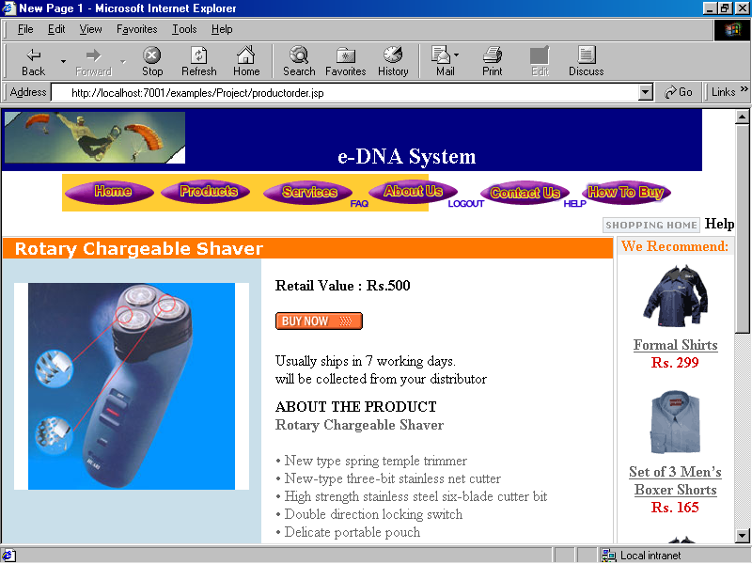

Fig. 3.16 Product Order Screen

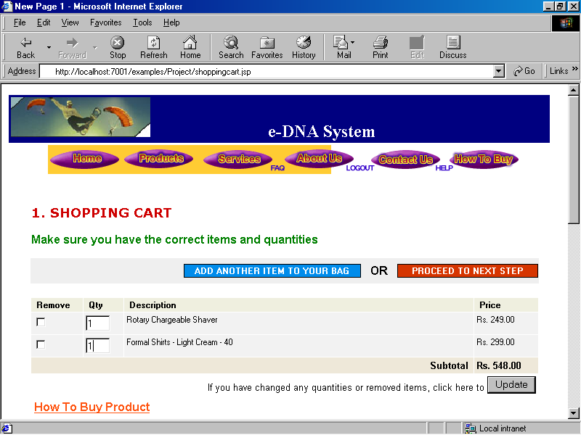

Fig. 3.17 Shopping Cart

3.3 OUTPUT DESIGN

Output design is the most important and direct source of information to the user. Efficient, intelligible output design should improve the system’s relationship with the user and it helps to make the decision. The outputs may be the processed data or sometimes the retrieval of the stored data. The outputs that are generated should be accurate, reliable and free from errors. A major form of the output is the hard copy from the printer. Outputs should be designed according to the requirements of the user.
Output design is very important to design the web site for a company. Output design involves in “e-DNA”, as output forms that are displayed in any browser like Internet Explorer, Netscape Navigator etc.

3.3.1 FORM DESIGN
3.3.1.1 Admin module
The output design in admin module has the viewing facilities to view cumulative indent and other feedback forms generated by the distributor network using the output forms of “ View indent” and “ View feedback”. The distributor indent contains indent number, indent date, product id, Quantity of each product.
In Admin module, feedback from various distributors about the product delivery and relevant queries can be viewed.
3.3.1.2 Distributor Module
The output design of the Distributor module supports the distributors in the following day-to-day activities.
- To view Product indent from the resellers
- To view the accepted quantity of goods through “Accepted” category.
- To view the logistics information about the committed quantity of goods
- To view indent and comments from company and reseller.
In “View indent form”, the resellers’ cumulative indents were received. Based on the indent, the distributors will be processing the cumulative indent to the company.
The Distributor could view the status of the indent from the company. The view status contains details like indent number, indent date, quantity ordered, accepted quantity, on process quantity.
The logistics settings for the indent from company could also viewed by the distributor. The logistics contains distributors indent number, the date of delivery.
The distributor could view the different comments from their reseller network through their inbox in mailing system.
3.3.1.3 Reseller Module
The output design of the Reseller module has been designed to support the reseller network through the following facilities
- To view the enquires generated from the customers
- To view the status of indent updated by distributors
- To view the logistics of the indent according to the delivery commitments
- To view the comments sent by the customers and distributors.

3.3.2 REPORT DESIGN
Output design involves in preparing reports. The developed system supports the network to generate reports like daily, weekly, monthly and day to day reports based on frequently moving products, cumulative indent of distributor, reseller who are involving in the indent making process.
The daily report gives the particular day’s report based on particular distributor or reseller’s cumulative indent. The indents generated by various distributors, reseller’s are viewed. For a particular product, the ordered quantity of total can be calculated.
The weekly report gives the particular week’s report based on the week’s cumulative indent and it is very useful while calculating the month’s report.
The sales report which gives overall sales for the company for particular day, week, month and day to day report. According to the sales report, the company can scale their company’s overall sales. The frequently moving products could be judged using sales report.

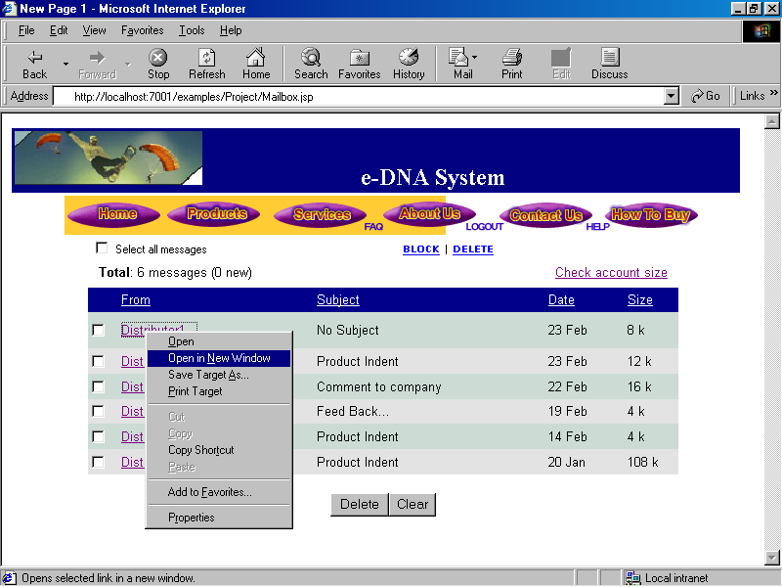

Fig. 3.18 Mailbox

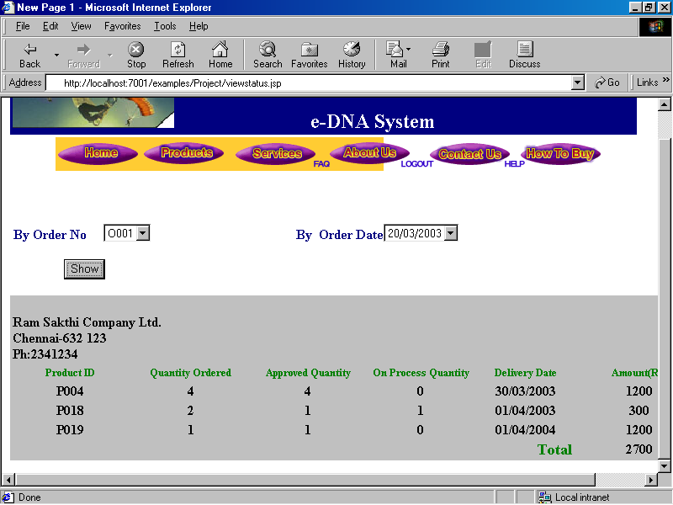

Fig. 3.19 View Order Status
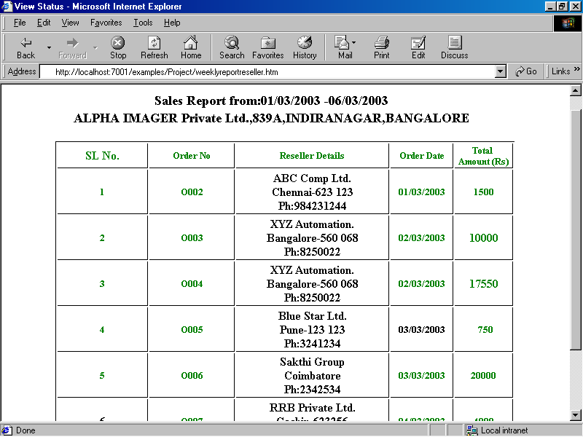

Fig. 3.20 Sales Report of Reseller

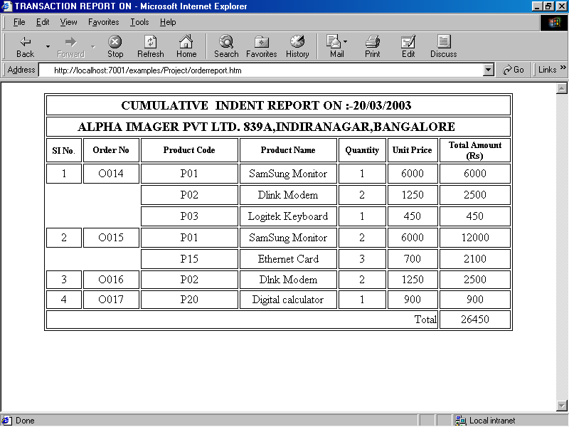

Fig. 3.21 Cumulative Indent Report
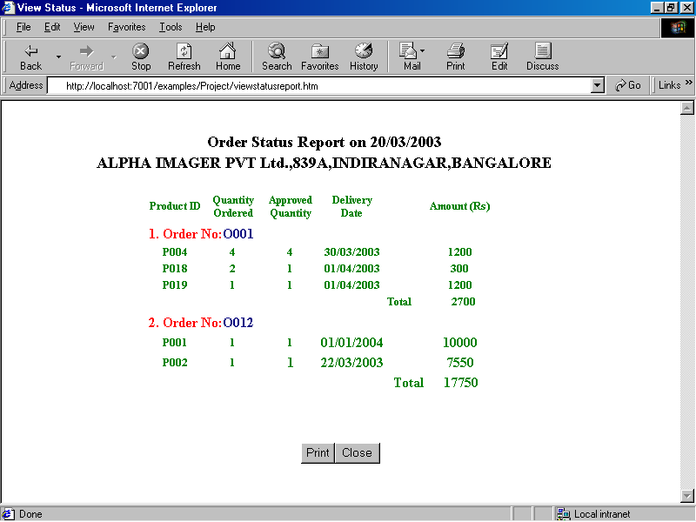

Fig. 3.22 Order Status Report

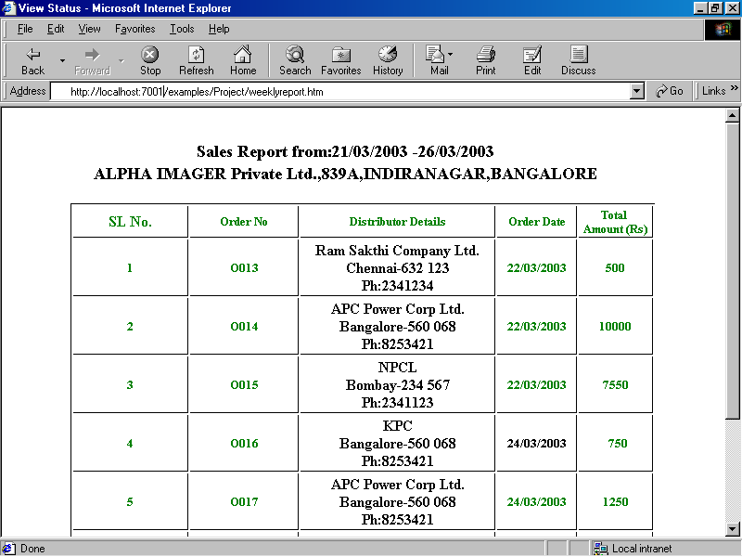

Fig. 3.23 Sales Report of Distributor

  - DATABASE DESIGN

The main objectives of designing a database are:
- Data integration
- Data integrity
- Data independence

Data integration
In a database information from several files is co-ordinate, accessed and operated upon as though it is single file. Logically, the information is centralized, physical; the data may be located on different devices connected through data communication facilities.

Data integrity
Data integrity means storing all the data in single place and allows each application to access it. This approach results in more consistent, on update being sufficient to achieve a new record status for all the applications, which use it. This leads to less data redundancy, data items need not be duplicated, a reduction in the direct access storage requirement.

Data independence
Data independence is the insulation of application programs from changing aspects of physical data organization. This objective seeks to allow changes in the content and organization of physical data without reprogramming of applications and to allow modifications to application programs without reorganizing the physical data.
The tables needed for each module and the specifications are signed. The specification of each and every column is given based on the details collected during record specification of each column was given based on the records and the details collected during record inspection during system study.
Normalization
Normalization is a series of tests use against the data to eliminate redundancy and make sure the data is associated with the correct table or relationship. The “e-DNA” system all tables are in third normal form. When data passes the first test, it is considered to be in first normal form. When it passes the second test, it is in second normal form and so on.
  - Data in first normal form
    - Remove repeating data from tables and relationships.
    - From the removed data, create one or more tables and relationships.
  - Data in second normal form
    - Identify tables and relationship with more than one key.
    - Remove data that depends on only one part of the key.
    - From the removed data, create one or more tables and relationships.
  - Data in third normal form
    - Remove that depends on other hand in the table or relationship and not on the key.
From the removed data, create one or more tables and relationships.

3.4.1 E-R Diagram

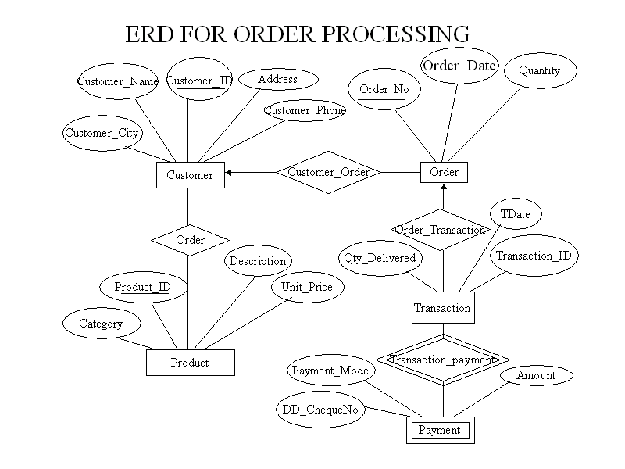

Fig. 3.24 E-R Diagram for Order Processing
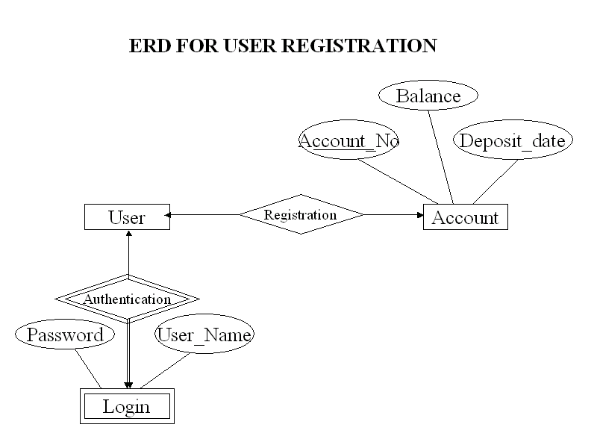

Fig. 3.25 E-R Diagram for User Registration
3.4.2 Table Layouts

Table Name : USER

Description : User table is used to store the details of various users such as Distributor, Reseller, and Customer.

FIELD NAME | TYPE | CONSTRAINTS
User_ID | Varchar2 (5) | Primary Key
Name | Varchar2 (50) | Not Null
Comp_Name | Varchar2 (50) | Not Null
Address | Varchar2 (100) | Not Null
Shipping_Address | Varchar2 (100) | Not Null
City | Varchar2 (50) | Not Null
State | Varchar2 (50) | Not Null
Zip_Code | Number | Not Null
Phone | Varchar2 (13) | Not Null
Fax | Varchar2 (13)
Email | Varchar2 (30) | Not Null
DOB | Date

Table 3.1 User Table

Table Name : LOGIN

Description : Login table used to store the user login details such as user ID, username, password, hint question & hint answer.

FIELD NAME | TYPE | CONSTRAINTS
User_ID | Varchar2 (5) | Foreign Key (USER)
User_Name | Varchar2 (20) | Not Null
Password | Varchar2 (15) | Not Null
Hint_Question | Varchar2 (30) | Not Null
Hint_Answer | Varchar2 (10) | Not Null

Table 3.2 Login Table

Table Name : USER_CATEGORY

Description : User_category table used to store the type of the user.

FIELD NAME | TYPE | CONSTRAINTS
User_ID | Varchar2 (5) | Foreign Key (USER)
User_Type | Varchar2 (2) | Not Null

Table 3.3 User_Category Table

Table Name : REGISTRATION

Description : Registration table used to store Distributor as well as Reseller registration information such as Central sales tax number, State sales tax number, Registration Date.

FIELD NAME | TYPE | CONSTRAINTS
User_ID | Varchar2 (5) | Foreign Key (USER)
CST_No | Varchar2 (10) | Not Null
Reg_Date | Date | Not Null

Table 3.4 Registration Table

Table Name : PRODUCT

Description : Product table contain various product information such as Product_ID, Product Name etc.

FIELD NAME | TYPE | CONSTRAINTS
Product_ID | Varchar2 (6) | Primary Key
Product_Name | Varchar2 (20) | Not Null
Category | Varchar2 (15) | Not Null
Description | Varchar2 (75)
Unit_Price | Number | Not Null
Mdate | Date | Not Null

Table 3.5 Product Table

Table Name : PRODUCT_STATUS

Description : Product_status table used to store availability of the product.

FIELD NAME | TYPE | CONSTRAINTS
Product_ID | Varchar2 (6) | Foreign Key (PRODUCT)
Available_Quantity | Number | Not Null

Table 3.6 Product_Status Table

Table Name :ORDER_MASTER

Description : Order_Master table used to store order information such as OrderID, Quantity Ordered, Product details etc.

FIELD NAME | TYPE | CONSTRAINTS
Order_No | Varchar2 (6) | Primary Key
User_ID | Varchar2 (15) | Foreign Key (USER)
Odate | Date | Not Null
Product_ID | Varchar2 (6) | Primary Key (PRODUCT)
Quantity | Number | Not Null

Table 3.7 Order_Master Table

Table Name :ORDER_TRANSACTION

Description : Order_Transaction table used to store transaction details of the order.

FIELD NAME | TYPE | CONSTRAINTS
Transaction_ID | Varchar2 (6) | Primary Key
Order_No | Varchar2 (6) | Foreign Key (ORDER_MASTER)
Qty_Delivered | Number | Not Null
Ddate | Date | Not Null

Table 3.8 Order_Transaction Table

Table Name :ORDER_STATUS

Description :Order_Status table contain information such as status of the order .

FIELD NAME | TYPE | CONSTRAINTS
Order_No | Varchar2 (6) | Foreign Key (ORDER_MASTER)
Product_ID | Varchar2 (6) | Foreign Key(PRODUCT_MASTER)
Acc_Qty | Number | Not Null
Onprocess_Qty | Number | Not Null

Table 3.9 Order_Status Table

Table Name :LOGISTICS

Description : Logistics table having the details of the logistics such as Order Number, Transaction Mode, Batch Code, Package Number, Container Number etc.

FIELD NAME | TYPE | CONSTRAINTS
Order_No | Varchar2 (6) | Foreign Key (ORDER_MASTER)
Transport_Mode | Varchar2 (10) | Not Null
Batch_Code | Varchar2 (6) | Not Null
Pack_No | Varchar2 (10) | Not Null
Container_No | Varchar2 (10) | Not Null
Container_Name | Varchar2(30) | Not Null

Table 3.10 Logistics Table

Table Name :FEEDBACK

Description : Feedback table used to store the customer feedback information

FIELD NAME | TYPE | CONSTRAINTS
User_ID | Varchar2 (6) | Foreign Key (USER)
Comment | Varchar2 (75) | Not Null
Subject | Varchar2 (15) | Not Null

Table 3.11 Feedback Table

Table Name :CREDITCARD_DETAILS

Description : Credit card details table contain information such as Card type, Number, Security Code, Expiry date etc.

FIELD NAME | TYPE | CONSTRAINTS
User_ID | Varchar2 (6) | Foreign Key (USER)
Ccard_Type | Varchar2 (2) | Not Null
Ccard_Number | Varchar2 (15) | Not Null
Expiration_Date | Date | Not Null
Security_Code | Varchar2 (3) | Not Null
Card_Holder_Name | Varchar2 (30) | Not Null

Table 3.12 CreditCard_Details Table

Table Name :ACCOUNT

Description : Account table used to store account details of the user.

FIELD NAME | TYPE | CONSTRAINTS
Account_No | Varchar2 (6) | Primary Key
Balance | Number | Not Null
Deposit_Date | Date | Not Null
User_ID | Varchar2 (6) | Foreign Key (USER)

Table 3.13 Account Table

Table Name :PAYMENT

Descriptiopn : Payment table contain information such as Payment Mode, Amount, DD/Cheque details etc.

FIELD NAME | TYPE | CONSTRAINTS
Transaction_ID | Varchar2 (6) | Foreign Key (ORDER_TRANSACTION)
Amount | Number | Not null
Payment_Mode | Varchar2 (20) | Not Null
DD_ChequeNo | Varchar2 (20) | Not Null

Table 3.14 Payment Table

Table Name :BILL_DETAILS

Description : Bill_Details table having the details of various bill such as Bill No, Bill date, Total Amount etc.

FIELD NAME | TYPE | CONSTRAINTS
Bill_No | Varchar2 (6) | Primary Key
Date | Date | Not Null
User_ID | Varchar2 (6) | Foreign Key (USER)
Order_No | Varchar2 (6) | Foreign Key (ORDER_MASTER)
Net_Amount | Number | Not Null

Table 3.15 Bill_Details Table

Table Name :MAIL_STATUS

Description : Mail_Status table contains the details of whether the mail is checked or not.

FIELD NAME | TYPE | CONSTRAINTS
ID | Varchar2 (6) | Primary Key
Checked | Varchar2 (5) | Not null

Table 3.16 Mail_Status Table

CHAPTER 4

SYSTEM DEVELOPMENT

System development is a series of operations performed to manipulate data to produce output form computer system. This aim at translating the design of the system produced during design phase intro the code in user programming language. A modular approach is used for the development of the software.

4.1 DEVELOPMENT PHASE

The development phase for the project was created from the specifications prepared during the design phase. A principal activity of the development phase is coding and testing the computer programs that make up the computer program component of the overall system. Other important activities include implementation planning, equipment acquisition and system testing .The development phase concludes with development phase report and user review.
Module wise description:
Major Modules:
- Administration
- Distributor Networking Administration
- Reseller Networking Administration
- Automatic Mailing
- Searching System
4.1.1 Administration Module
The Administration module of the project handles various day-to-day approval process of the company and it also handles the Registration process for the entire network starting from company, distributor & reseller. The company will be creating such registrations to have control on daily information to the channel network in both distributor level as well as reseller level.
Apart from user creation, any needed edition in the registration details will also be handled under Administration module only. The company will fix the distributor network for their products wherein the distributors will fix reseller network and such information will be passed to the company to add in the reseller registration forms.
According to the functional flow of the system, any ideal customer might generate product enquiry through their reseller network and getting the goods also from the resellers. As a part of it, the reseller’s request is getting added in the distributors account and such cumulative indents are getting forwarded to the company. As a follow up process, the company would be checking such indents through the administration module to have followed up with basic stock modules.
After having the final indent, the proposed system supports the further transaction of the goods according to the request of the network which has been further supported by a well developed logistics system with necessary inputs such as date & time, container details and other delivery information with concerned batch code. As a part of pre - logistics system, the distributor network will be given commitment by the company about the quantity of goods approved for such transfer through a ‘set status’ option in the same module.
4.1.2 Distributor Networking Administration – DNA Module
Distributor Network Administration is the heart of the overall system, which is the bridging system between the resellers and the company. To support such bridging functions, the proposed system has viewing and updating routines for the indents of the reseller network. In general, any ideal distributor will be having more number of resellers to increase their sales in their allotted region and handling the concurrent enquires from such reseller network is really a complicated routine. But as the system has well defined viewing options for the indent, the cumulative indent can be easily generated.
This module will handle various distributor level routines on updating the regular reports, request for stock according to the cumulated intents of various resellers allotted under their network. Also they will be having facilities to see the status of their request, approval level of intent, and logistics information towards receiving the products from the company and mailing system control towards their reseller network. Also they will be having facilities to send late alerts to the company in case of delay in receiving the products according to the commitment of the company.
According to the indent produced, the company would be proceeding further with the product transfer in following ways.
- Viewing the product indent & making a cumulative indent to check with the current offline modules and other support routines.
- After getting the confirmation to move the goods for any fixed date, the admin module will fix the set status through “Approved” & “on Process” modes.
- All the above details are viewed by the Distributor Network through ‘view status’ of the DNA system, which helps the distributors to proceed with the delivery commitments with their reseller network.
- As a part of further process, the DNA system has the facility to view the mode of logistics and relevant date commitments, container details & other delivery details with concerned batch code and the distributors will commit the delivery of goods to their reseller network accordingly.
4.1.3 Reseller Networking Administration – RNA Module
Reseller Network Administration is the final stage of overall automation which is customer centered by nature. The defined RNA system only proves the existence of intermediate system by acting as a bridging component between the customers and the distributors. It also supports the online market of the company as it is being the receiving end of the mails sent by the customers and even it could be the demonstration end for the products as it is directly linked with the customer base.
In addition to that, the RNA system has viewing facilities of initial level enquire generated by the customers and it also has facility to send the cumulative indent to the DNA system. In general, any ideal reseller will be getting multiple enquires for same product in a day and any such reseller would handle more than one product for sales which is getting identified by concerned product id. In order to sort out such big hits to the final indent of the day towards DNA system, The RNA system has facility to furnish a well-defined ‘order id’ format to make a unique flow in the entire system.
According to the enquiry generated by the online customers, the reseller would be proceeding further with the product transfer in following ways.
- Checking the customer’s enquiry and making the cumulative indent. Forwarding the cumulative indent to the DNA system and waiting for the further commitment from the distributors to proceed further with the product delivery.
- Viewing the ‘view status’ of DNA system to see the commitment of the distributor with logistics information. Fixing the ‘Set Status’ of RNA system to commit the delivery date of the product and relevant demonstrations.
4.1.4 Mailing System
Mailing System is the basic building block of the entire system. The mailing system covers the scope of automatic mailing as well as its offline facilities. The use of automatic mailing system starts from the customer enquiry form. It is very clear that the customer is not directly dealing with the company at any given point of time and it is only through the reseller who fills the rest of the gap. So it needs a complete automated system from communication point of view and it has been proved that the developed mailing system could sustain for the purpose. As a part of further process, any indent produced from the reseller to the distributor end and the same from the distributor to company end is well communicated with a pre-defined system through automatic mailing system and also by its offline nature.
By taking the development scope of the mailing system, we can say that SMTP and pop3 protocols are being controlling protocols to fix necessary configuration in both online as well as online modules. As a complete communication module, the system not only supports the input features of the overall system but also supports to transfer the day to day reports which are getting generated from one end to another in effective way.
Features of the Mailing System
- Updating the reseller requirements to the distributors
- Updating the distributor requirements to the company
- Updating the various approval level in delivering the products in the entire network
- Updating the customer address book about the product delivery
- Controlling the entire network through various updates in production, sales & logistics to provide service on time.
4.1.5 Searching System
The online systems are functioning very effectively with more accuracy by means of its high-resolution databases from input level to output level. But it is very important from customer level to distributor or reseller level to have quick actions to increase the system reliability and control the time factor. This feature has been ensured by means of a built-in search engine in the proposed system, which has lot of advantages to influence the end-to-end processes.
In general, the online traffic has very quick migration on page by page and without having quick service; no promotions can be effectively converted into sales. By taking this into account, the proposed system has search engine facility to support the customers to search for right products within very less time and apply for the online form. This reduces the searching effort of the customer and would support him towards his purchase nature.
Features of Search Engine
- User can search the details of the particular product by putting searching string.
- This will also allow the user to choose the product category and automate the selection of appropriate reseller while the customer enters the address.

4.2 DEVELOPMENT PHASE ACTIVITIES

- Implement Planning
- Computer Program Design
- User Review
- Equipment acquisition and Installation
- Coding and Debugging
- Computer Program Testing
- System Testing
- Reference Manual Preparation
- Personal Training
- Changeover Plan Preparation
- Development Phase Report Preparation
- User Acceptance Review

CHAPTER 5

SYSTEM TESTING AND IMPLEMENTAION

The importance of software testing and its implication with respect to the software quality cannot be overemphasized. Error may occur at the very inception of the process, where the objectives may be erroneously or imperfectly specified, as well as in the design and development stages. Because of human inability to perform and communication with perfection, the software development is accompanied by a quality assurance activity.

5.1 TESTING

Testing is vital to the success of the system. System testing makes a logical assumption that if all the parts of the system are correct, the goal will be successively achieved. Inadequate testing leads to errors that may not appear a month later.
This create two problems:
1. The time lag between the cause and appearance of the problem.
2. The effect of system errors on files and records with in the system.
A small system error can conceivably explode into a much larger problem. Effective testing early in the process translates directly into long-term cost saving a reduced number of errors.
Another reason for system testing is its utility as a user-oriented vehicle before implementation. The best program is worthless if it does not meet the user needs. The system should be tested properly to see whether it meets the user needs. The system should be tested properly to see whether it meets user requirements.
Testing is carried at the following states during development.
- Function Level
- Module Level
Function Level testing is carried out during individual program development to test the functionality of the entire system and the efficiency of the system, while working with large volume of data.
Individual models were checked for system and programming errors. Whether the module is doing the intended work according to the requirement specification was also tested with help of sample data.
Module testing was carried out with under mentioned objectives:
- Module interface has to be tested after compete development.
- To test whether all the features provided in the module are performing satisfactorily.
- To check if on receipt of erroneous data appropriate error message are generated.
After the completion of the above-mentioned testing, Acceptance testing is carried out. Acceptance testing is running the system with live data by the actual user. Acceptance testing, issues like performance, user friendliness etc., are considered.
The Software testing is carried out in the developed system, “e-DNA” using the existing data. The output has been compared with the existing data and found to be matching well. The procedure of testing that has been use as follows:
The project “e-DNA ” is involving four levels of testing.
- Unit Testing
- Integration Testing
- Validation Testing
- System Testing
5.1.1 Unit Testing
Unit testing focuses verification effort on the smallest unit of Software design (i.e.), the module. Unit Testing exercises specific paths in a module’s control structure to ensure complete coverage and maximum error detection. This test focuses on each module individually, ensuring that it functions properly as a unit. Hence, the name is Unit Testing.
The Login form asks to enter the username and password. Here it checks the entered username and password with the registered members username and password. If it is correct, it allows the reseller and distributor to access their corresponding pages. Otherwise, access is denied.
5.1.2 Integration Testing
Integration Testing addresses the issues associated with the dual problems of verification and program construction. After the software has been integrated a set of high-order tests are conducted. The main objective in this testing process is to take unit tested modules and build a program structure that has been dictated by design.
In Registration form, each and every field of entry is tested. If the user forgets to enter any fields, it displays an alert Message to enter the left field. Here, we also test whether the username entered already exists or not. If it exists asks us to enter another username. We also check the number of characters for password field. If it exceeds eight, it gives an alert message to enter with in eight characters. The date of birth is also checked and accepts only if it is in dd-mm-yy format.
5.1.3 Validation Testing
The Login module asks to enter the username and password. Here it checks the entered user-id and password with registered members username and password. If it is correct, it allows the member to access the their pages. Otherwise, it won’t allow.
In Registration Module, each and every field of entry is tested. If the user forgets to enter any fields, it displays an alert Message to enter the left field. Here, we also test whether the Username entered already exists or not. If it exists asks us to enter another Username. We also check the number of characters for password field. If it exceeds eight, it gives an alert message to enter with in eight characters. The date of birth is also checked and accepts only if it is in dd-mm-yy format.
For almost every field the validity is checked to determine whether the given value is a valid one or not.

5.1.4 System Testing
System Testing is series of different tests whose primary purpose is to fully exercise the computer based System. Although each test has a different purpose, all the work should verify that all system elements have been properly integrated and perform allocated functions.

5.2 IMPLEMENTATION

Implementation is “the stage in which the theoretical design is converted into a working system”. The most crucial stage is achieving a new successful system and in giving confidence that the new system works efficiently and effectively. The first step in implementing the system is in getting the approval from the system manager.
When the initial design was done for the system, the user was consulted and a demonstration was given to them about the working of the system. The aim of the system illustration was to identify any incoherent logical flow by using various combinations of sample data. Processing accuracy and reliability checking were also made.
The implementation stage in a project involves:
- Careful planning
- Investigation of the current system and the constraints on implementation.
- Training the staff in the newly developed system.

5.2.1 Documentation

Before implementing the system two important documents needs to be prepared.
            - User Manual
            - System Manual

User Manual
The user manual creation for this “e-DNA” will help any user to understand the basic system functionalities and how to use it concepts in a user friendly way and part of it has been added in the FAQ’s as well as in HELP options.
At first time, the administrator is given password to the user. Admin has all rights to do all activities in the system. The administrator login has rights to create new user and change other users password etc., Users themselves change their passwords only that they knew their old password. If the users forgot their password, then they had asked about their password to administrator only. If a user forgets one’s user name and password, that user has to register again with the new user name and password.
The HELP Option will help the user to view the following error handling methods.
1. List the error messages and the appropriate action to be taken:
2. The error messages are given when the user enters the inappropriate values.
3. The details of error messages are given in the Help file that what type of error occurs and when it occurs.

System Manual
It explains all the aspects on design, which is useful mainly for the further maintenance of the system.
5.2.2 System Training and Demonstration
After the successful completion of acceptance testing, the system is ready to use. In order to put the system into use, the following activities should be taken care of.
- Preparation of User and System documentation
- User Training Kit
- Conducting system training with demonstration and hands on.

General training is given to the user. The main aim of the training would be to furnish the user with a working knowledge of the newly developed system. The users are trained to newly developed system. The user manuals are circulated to users.

CHAPTER 6

CONCLUSION

The proposed system “e-DNA “ has proved as a well-defined alternative for the existing system by overcoming its drawbacks and the system has been developed with ground realities. By adopting this concept, any company can increase their sales in an effective way without violating their existing channel network, also with their full co-operation. From the view of customers too, this proposed system has been well packed with more advanced features for their satisfaction and altogether the overall system will ensure a complete satisfaction from the reseller & distributor network as well as the customers also which is only the success of any company.

CHAPTER 7

SCOPE FOR FURTHER ENHANCEMENT

The Proposed system has so many advanced features than the existing system by means its reach and user friendliness. Apart from the features given in the proposed system, further extension and redesign can be done according to the client requirements. But we can draw few possible extension modules as a part of initial level suggestions to give a general idea to the clients who are implementing the project and those suggestions can be consolidated as follows.

Extension can be done in the technology aspects by using Data warehousing & Mining tools to adopt online databases for the end-to-end process, which will help the entire network to function faster. Extension can be done in the approach of more advanced logistics automation.

REFERENCES

- Elias M. Awad “Systems Analysis and Design”, Galgotia Publications Private Limited, 1994.
- Ivan Bayross “HTML,JavaScript”
- Jason Hunter “JAVA Servlet Programming”, Shroff Publishers and
Distributors Private Limited, 2000.
- James Goodwill “Pure Java Server Pages “, BPB publications, 2000
- Marco Pistoia, Reller “Java2 Network Security”
- Phil Hanna “JSP: The Complete Reference”, Tata McGraw Hill, 2000
- Patrick Naughton and Herbert Schildt “Java2 The Complete Reference”, Tata McGraw Hill, 2000.
- Roger S Pressman “Software Engineering”
- Richard Monson-Haefel Enterprise JavaBeans, O’Reilly, Second Edition

Web Sites
- http://www.google.com
- http://www.java.sun.com
- http://www.oracle.com
- http://www.winncom.com

